**Screenshots – IMeet Project**

**Initial / Home Screen**

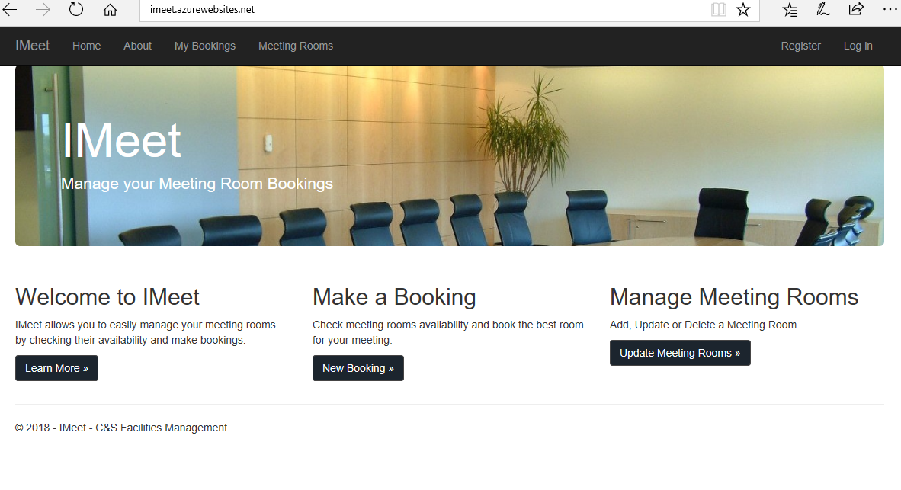

**About Screen / Welcome to IMeet – Learn More**

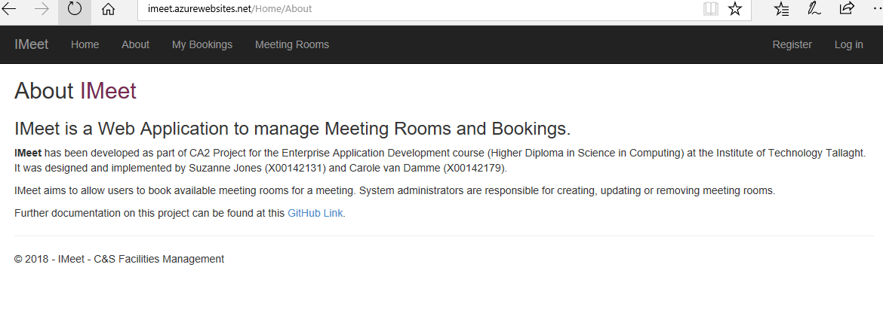

**My Bookings / View Future Bookings Screen – Initial Logon**

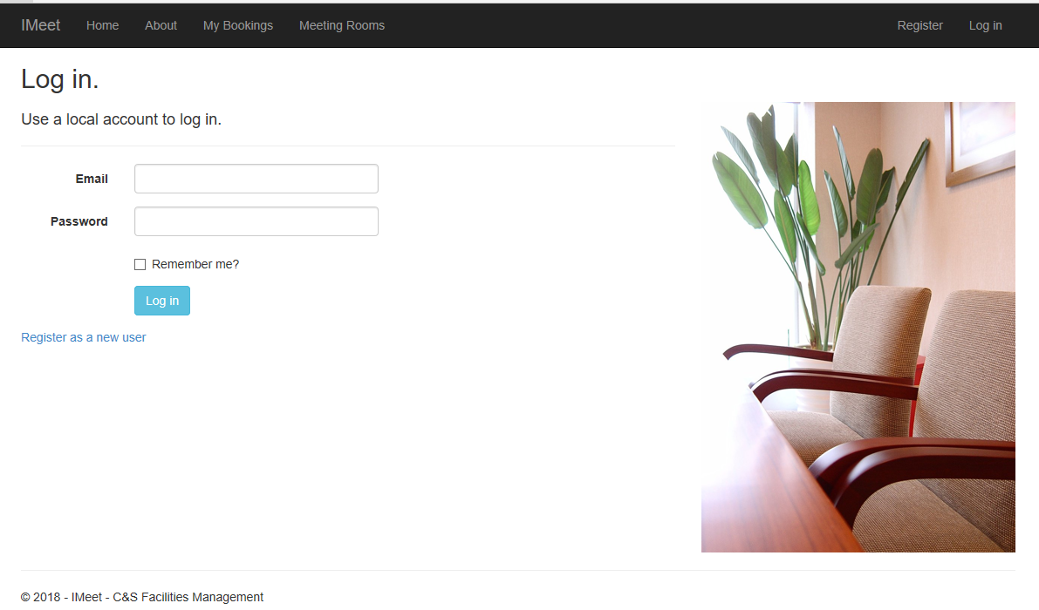

**My Bookings / View Future Bookings Screen - Can Create Booking / Edit / Cancel Room Booking from here**

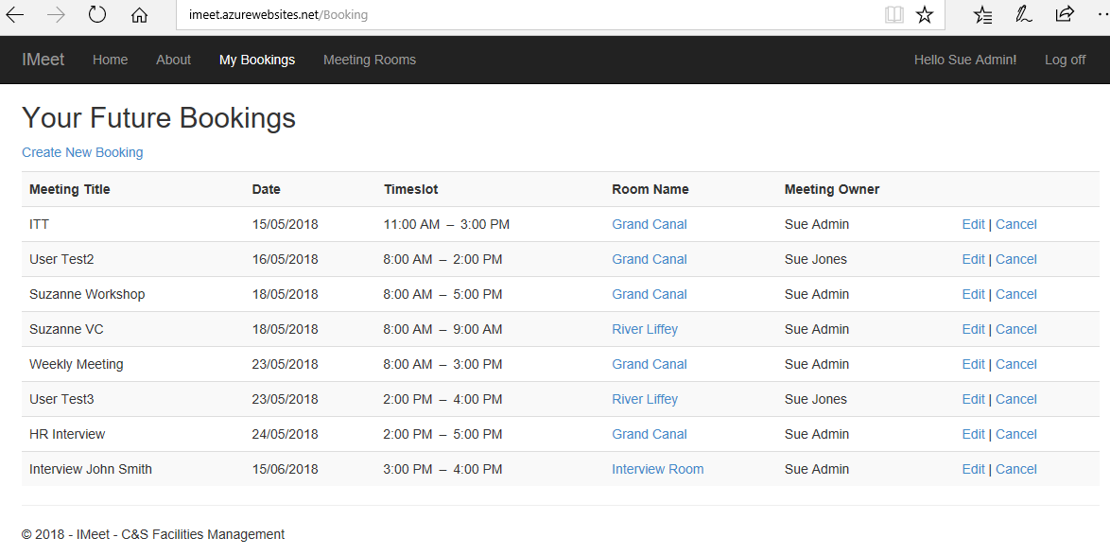

**My Bookings / View Future Bookings Screen / Create New Booking / Find Room – Select ‘Create Meeting’**

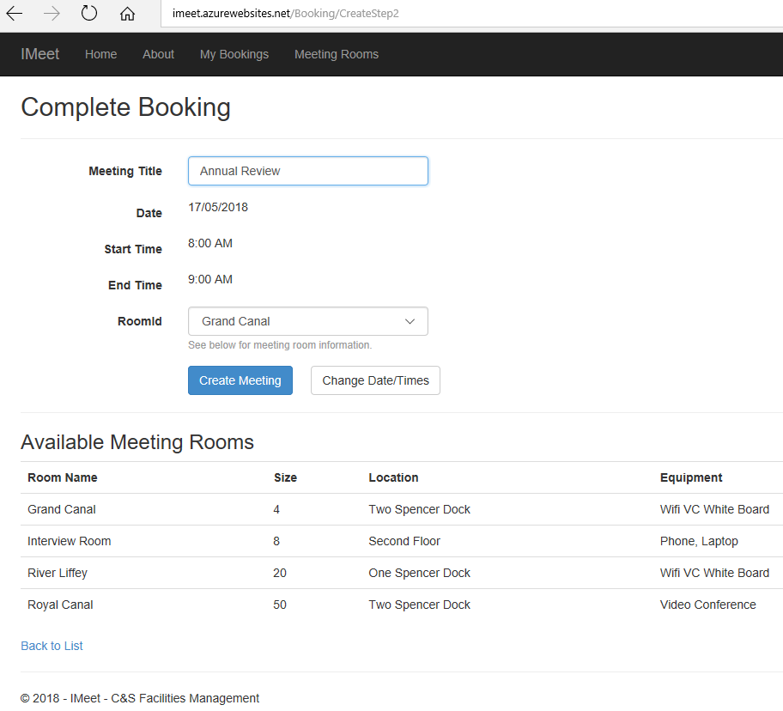

**Meeting Rooms Screen – Initial Logon**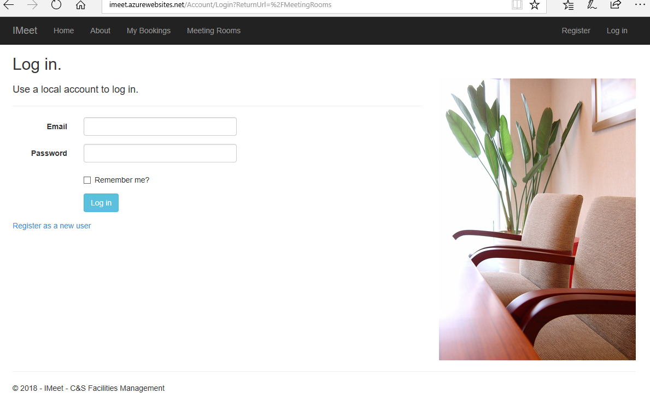

**Meeting Rooms Screen – After Logon.**

**An Admin user can add a new meeting room and Delete**

**A regular user can only see, edit and delete their own bookings**

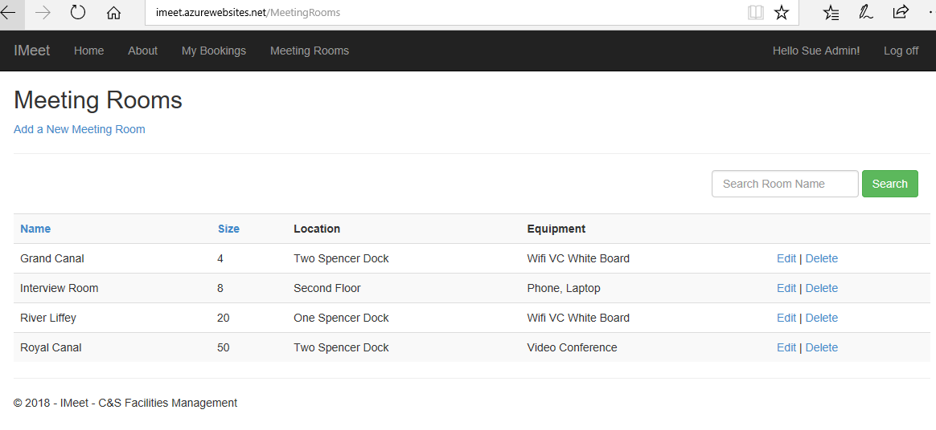

**Add a new Meeting Room – Select Create to Save * Admin task only**

